California Housing Dashboard Documentation
Statistical Analysis Page
This page shows statistical analysis discoveries from the dataset. It is completely interactive within the visuals and the housing age filter.
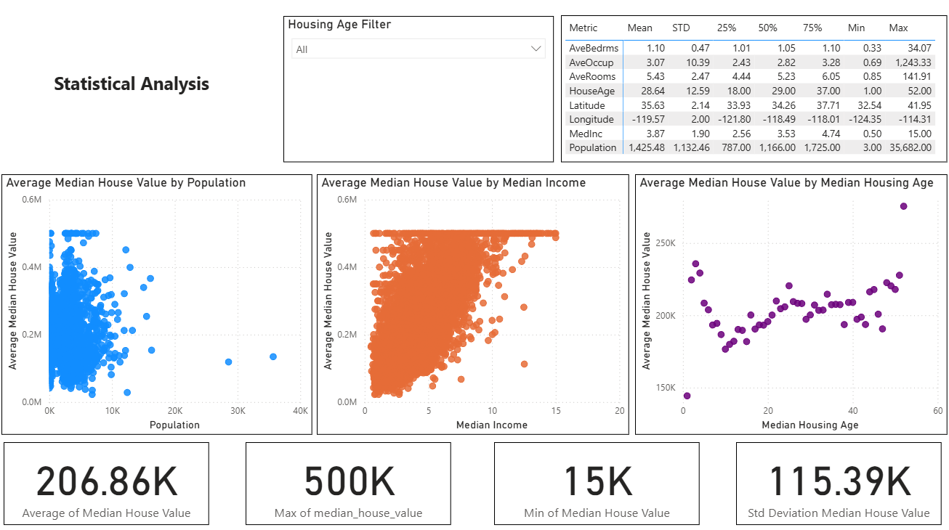
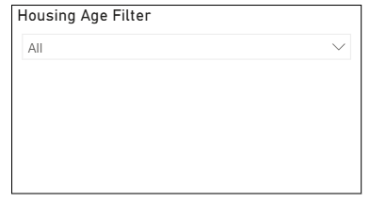
- Housing Age Filter lets you filter the other visuals on the page to display for the Housing Age chosen.
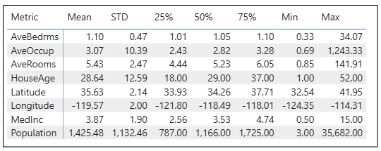
- Statistical Summary metrics show the metrics for each feature.

A takeaway from this matrix is that this dataset really captures a variety of districts. I can see that is the case from the maximum and minimum metrics for most features.
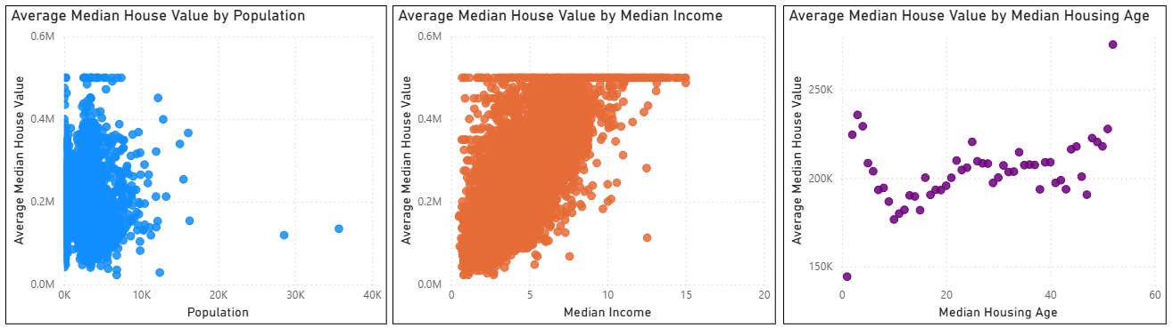
- Three scatterplots that each show a feature by the Average Median House Value. The features are Population, Median Income, and Median Housing Age.

A takeaway from specifically Median House Value Vs Median Income is that, as to be expected, house value goes up with median income.
- Metrics of the Median House Value. These boxes show the average Median House Value, maximum Median House Value, minimum Median House Value, and Standard Deviation Median House Value.
A takeaway from these data points is that once again the representation of the dataset stands out between the minimum and maximum house values.
EDA Findings Page
The EDA Findings page shows evaluations of features predicting the Median House Value over multiple models.
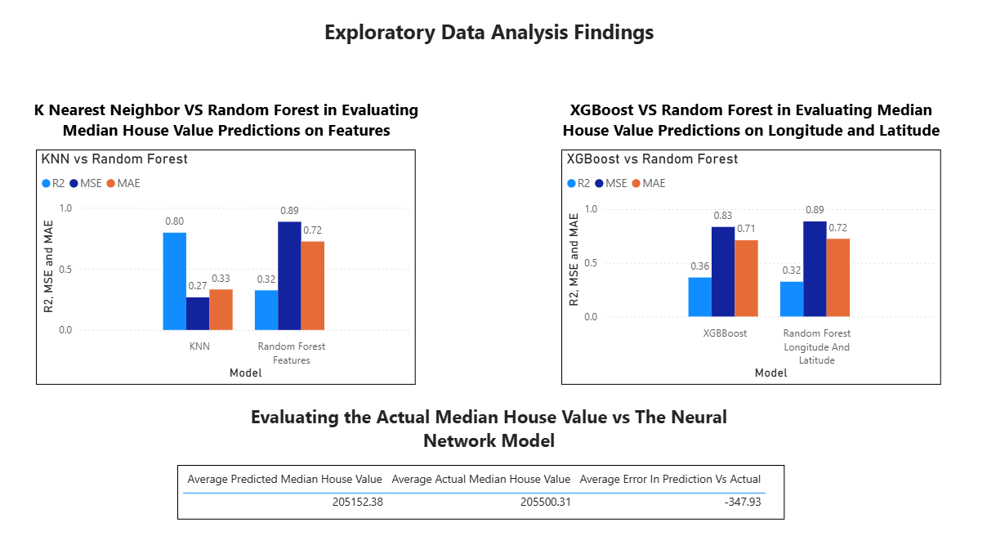

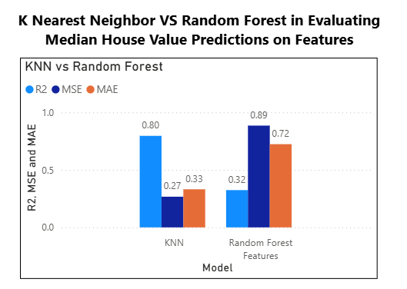
- This bar plot shows the evaluation of Median House Value predictions using Average Rooms, Population, Occupancy, and House Age, between two different models, K Nearest Neighbor and Random Forest. The predictions are measured in Mean Squared Error, Mean Absolute Error, and R2 Score.
A takeaway from these bar plots is that the KNN Model performs much better than Random Forest Model in every aspect.
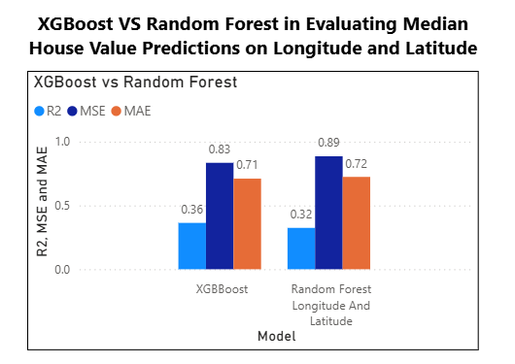
- This bar plot shows the evaluation of Median House Value predictions using Longitude and Latitude, between two different models, XGBoost and Random Forest. The predictions are measured in Mean Squared Error, Mean Absolute Error, and R2 Score.
A takeaway from these bar plots is that Random Forest and XGboost are not the best models for this dataset.
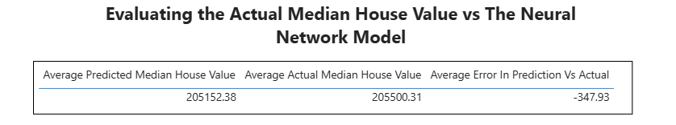
- This visual shows the Neural Network Model’s accuracy in predicting the Median House Value.

A takeaway from this visual is that the Neural Network Model is very accurate in predicting the Median House Value.

Districts Surveyed Map Page
- This page shows a map of California with the latitude and longitude of the districts surveyed shown on the map.
A takeaway from this map is that the closer to the coast the more housing districts there are.
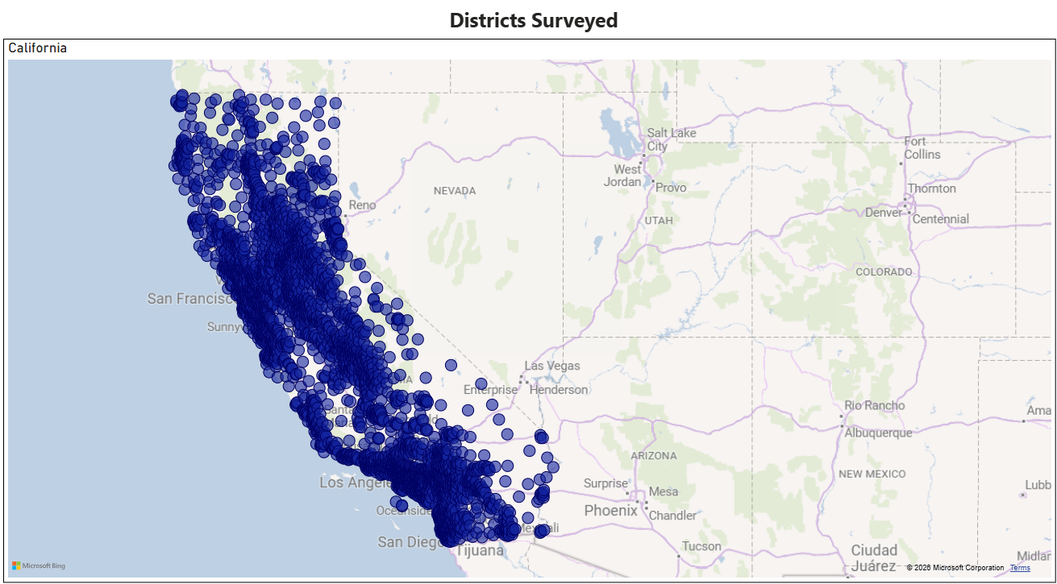

Correlation Matrix Page
This page shows the correlation matrix as well as statistics on the matrix metrics themselves.
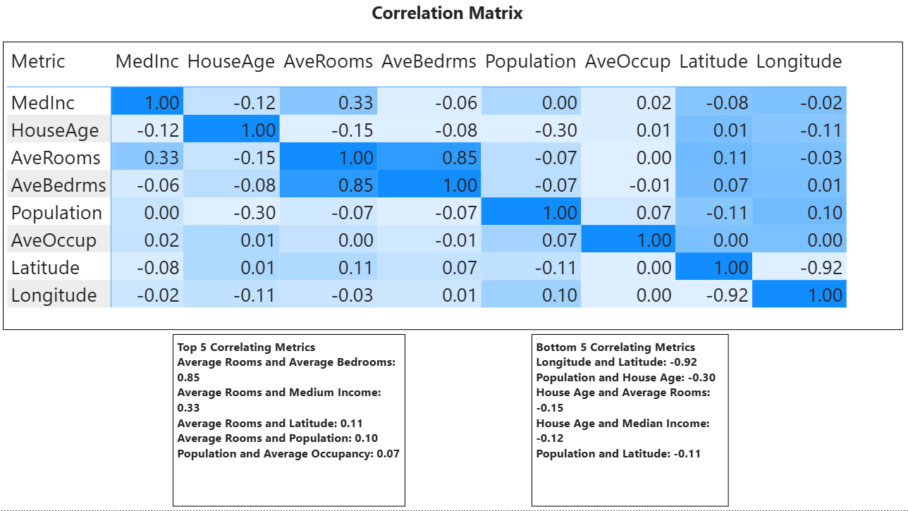
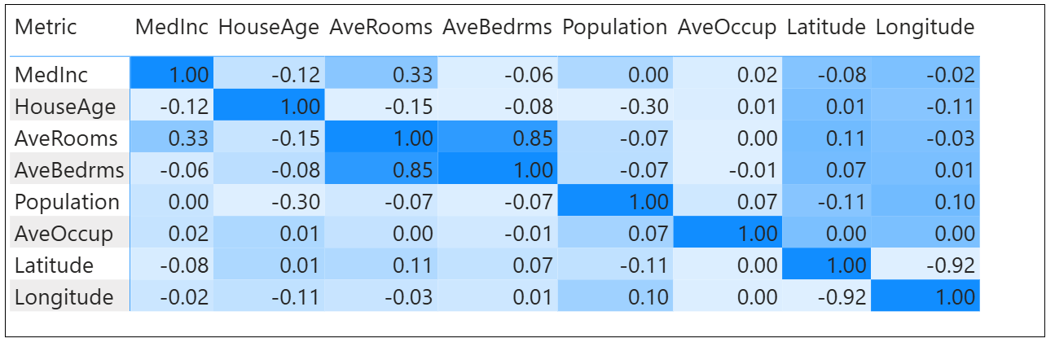
- The Correlation Matrix in Heatmap style showing the correlation between features.
A takeaway from the correlation matrix is that Average Rooms and Average Bedrooms would be closely related since A bedroom makes up a room.
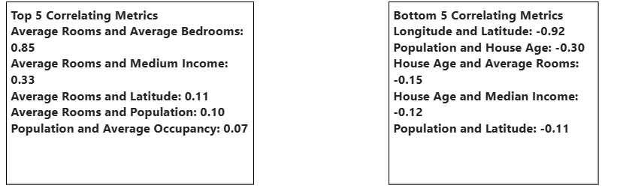
- Statistics on the top and bottom 5 correlating metrics.
A takeaway from these statistics is that House age is something that wouldn’t correlate with population of each district since a houses age does not normally affect the amount of people that live in an area.
Scenario Predictions Page
- Each scenario prediction against the baseline average
A takeaway from the scenario predictions in that Higher Population density had a surprising effect on the median housing value

Appendix
- Housing Age Filter
- Summary Statistics
- Median House Value by Features Scatter Plots
- Median House Value Statistics
- KNN Vs Random Forest evaluation for Median House Value
- XGBoost Vs Random Forest evaluation for Median House Value
- Neural Network Evaluation for Median House Value
- Districts Surveyed Map
- Correlation Matrix Heatmap
- Correlation Matrix Statistics
- Scenario Predictions

